SQL COMMAND

LAB ASSIGNMENT

MITHUN.K (3152113065)

1) CREATE THE FIRST TABLE CLIENT_MASTER:

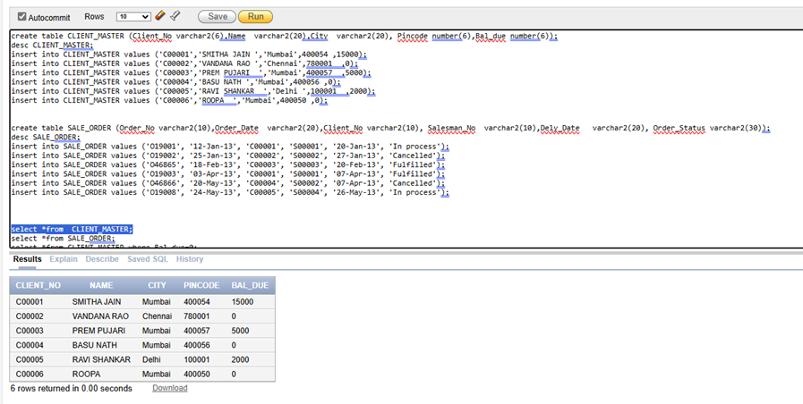

2) CREATE ANOTHER TABLE SALE_ORDER

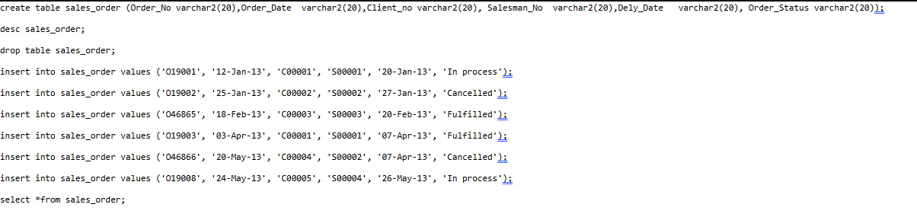

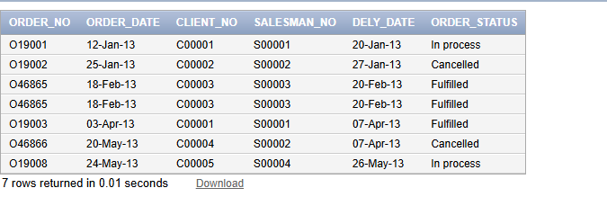

3) LIST ALL DETAILS FROM THE CLIENT MASTER TABLE FOR CLIENTS WHOSE BAL_DUE=0;



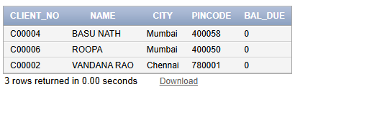

4) UPDATE TABLE CLIENT MASTER CHANGE CITY OF CLIENT NO C00004 TO JAIPUR

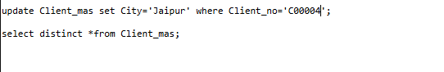

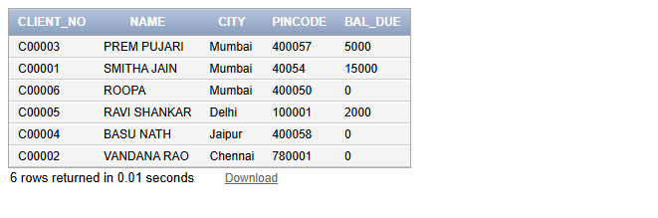

5) RETRIEVE ECORDS OF CLIENTS RESIDING IN MUMBAI



